Chapter 10, Problem 39.

Find I₁, I₂, I₃, and I_{x} in the circuit in Fig. 10.84.

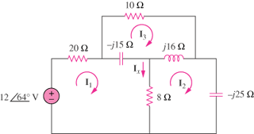

Figure 10.84
For Prob. 10.39.

